1.

SELECT no, katalog.jenis, supply, barang_masuk

FROM `katalog`

JOIN obat ON katalog.jenis = obat.jenis

JOIN supply ON supply.kode_barang = katalog.supply

ORDER BY no ASC

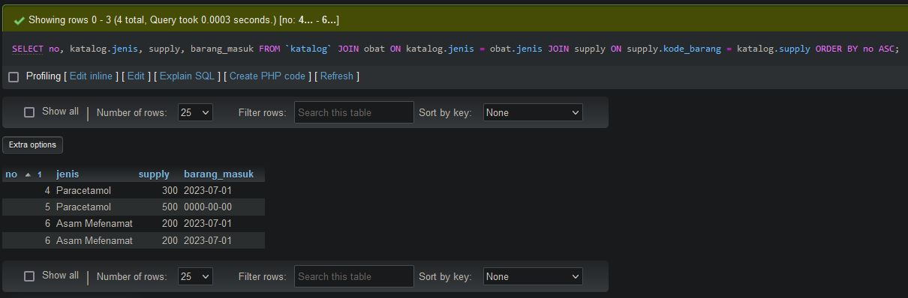

2.

SELECT no, katalog.jenis, supply, barang_keluar

FROM `katalog`

RIGHT JOIN obat ON katalog.jenis = obat.jenis

JOIN supply ON supply.kode_barang = katalog.supply

ORDER BY no ASC

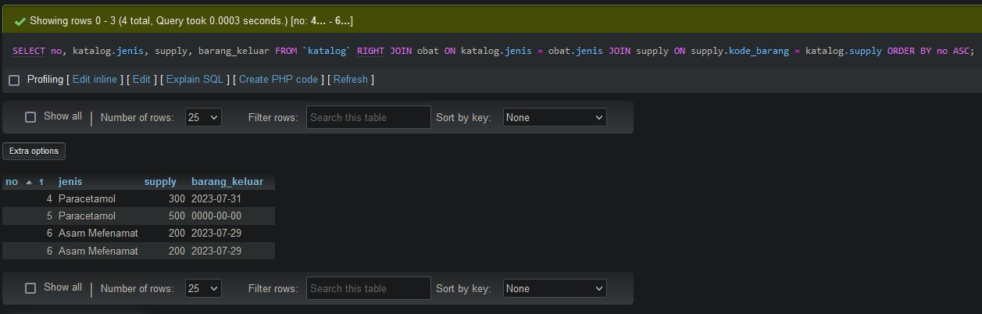

3.

SELECT no, katalog.jenis, supply , barang_masuk, barang_keluar

FROM `katalog`

LEFT JOIN obat ON katalog.jenis = obat.jenis

JOIN supply ON supply.kode_barang = katalog.supply

ORDER BY no DESC

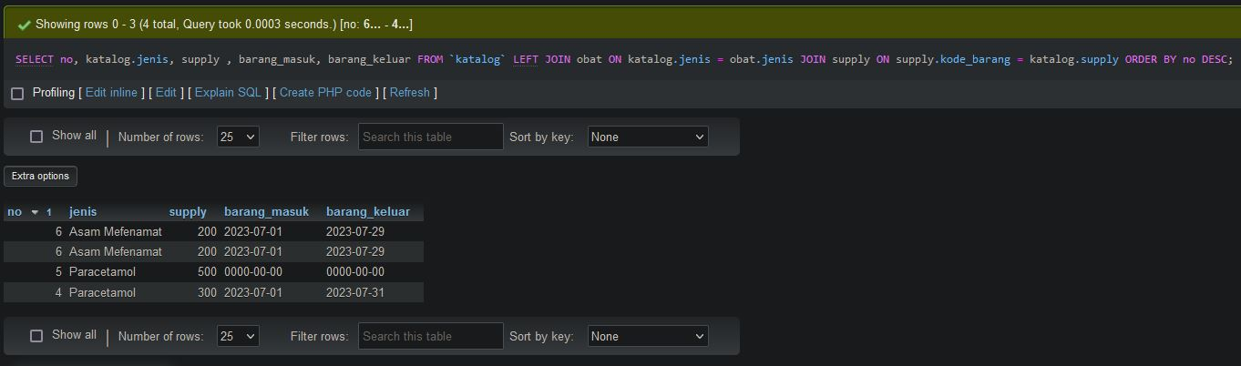

4.

SELECT no, katalog.jenis, supply, barang_masuk, barang_keluar, nama_barang

FROM `katalog`

JOIN obat ON katalog.jenis = obat.jenis

JOIN supply ON supply.kode_barang = katalog.supply

WHERE supply LIKE '%3%'

ORDER BY no ASC

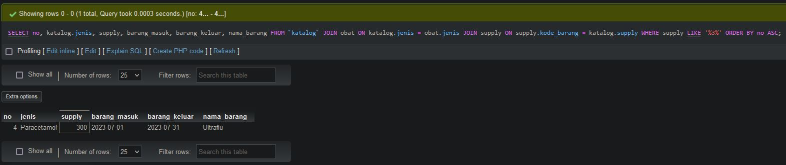

5.

SELECT kode_produksi, obat.jenis, exp

FROM `obat`

JOIN supply on obat.jenis = supply.barang_masuk

JOIN transaksi ON transaksi.no_transaksi = supply.stok_barang

JOIN katalog ON katalog.no = transaksi.harga_barang

WHERE exp LIKE '%07%'

ORDER BY kode_produksi DESC

